Template for a Title List
The Government of the Russian Federation
Federal State Autonomous Institution for Higher Professional Education National Research University Higher School of Economics
St. Petersburg Branch
St. Petersburg School of Economics and Management

Zhitnikov Danila
Khoshimov Mark
Panchenko Anastasia

Corporate Default Prediction
Using SNA and GraphSAGE

Term paper for Course:
Social Network Analysis
Master’s Programme “Finance”
Research Supervisor
I. Karpov

Saint Petersburg - 2026

1. Abstract
This report studies the problem of corporate bankruptcy risk prediction using Social Network Analysis and graph machine learning. The main goal is to test whether a network contagion effect exists: the financial condition of a firm may depend not only on its internal indicators, but also on the topology of its relationships with counterparties.
The project implements a Python-based pipeline that includes inductive extraction of structural graph features, training of a Random Forest baseline, and training of a GraphSAGE model. To prevent data leakage, graph features for the baseline are extracted with respect to the train, validation, and test split. The model comparison also accounts for class imbalance by choosing the classification threshold on the validation set using the precision-recall curve.
The results show that Random Forest with graph features achieves very high Recall of about 94%, which means it detects most bankrupt companies. GraphSAGE demonstrates higher Accuracy of about 75% and a slightly higher PR-AUC. Overall, the study confirms the predictive value of network analysis for corporate credit risk scoring.

2. Introduction and Relevance
Corporate bankruptcy prediction is important for banks, investors, suppliers, and regulators. Incorrect risk assessment can lead to financial losses and higher systemic risk.
Traditional default prediction models usually rely on internal firm-level indicators such as revenue, debt ratio, liquidity, credit score, and legal cases. However, a company does not operate in isolation. It is connected to suppliers, partners, directors, investors, and parent companies.
Therefore, in this project each company is represented as a node in a graph, while corporate relationships are represented as edges. This approach makes it possible to evaluate not only the condition of an individual company, but also its position inside the corporate network.
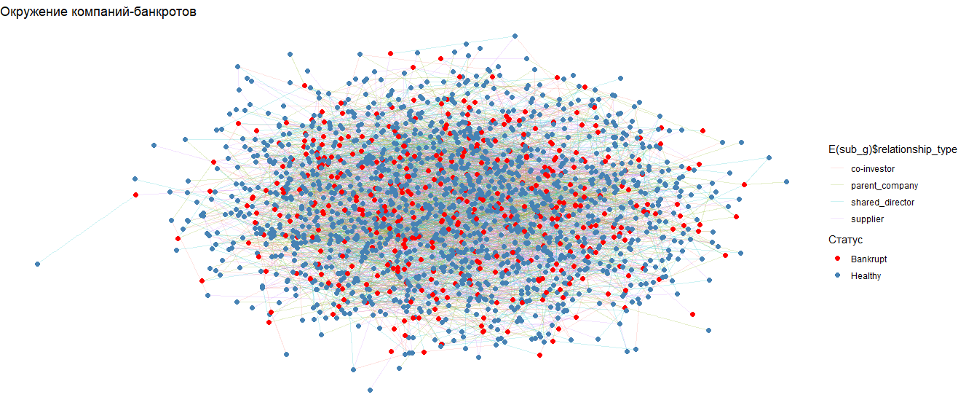
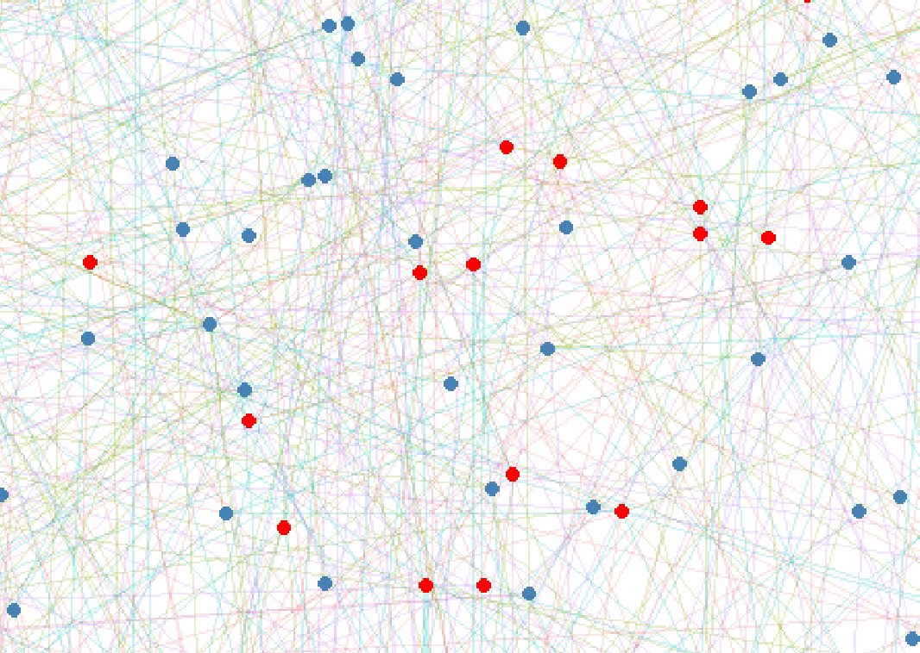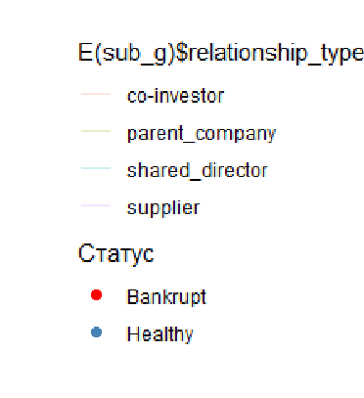
Figure 1. Example of the corporate graph: nodes represent companies and edges represent corporate relationships.

3. Research Problem and Hypothesis
Research problem: can bankruptcy prediction be improved by using the structure of the corporate network?
Hypothesis H1: the structure of corporate relationships contains additional signal about bankruptcy risk. If a company is connected to risky counterparties or occupies a vulnerable position in the network, its probability of default may be higher.
The hypothesis is tested by comparing two approaches: a classical Random Forest model with financial and graph features, and a graph neural network model based on GraphSAGE.

4. Dataset Description
The dataset consists of a company table and a corporate relationship table. Each company is a node in the graph, and each relationship between two companies is an edge.
Component | Description
Nodes | 2 934 companies
Edges | 9 000 original corporate relationships
Target variable | bankrupt: 1 = bankrupt, 0 = non-bankrupt
Node features | revenue, debt_ratio, liquidity, legal_cases, credit_score
Edge features | relationship_type, weight, interaction_freq
Relationship types | supplier, shared_director, co-investor, parent_company

The target variable is imbalanced: bankrupt companies are the minority class. For this reason, PR-AUC is used as the main metric because it is more informative for rare positive classes.
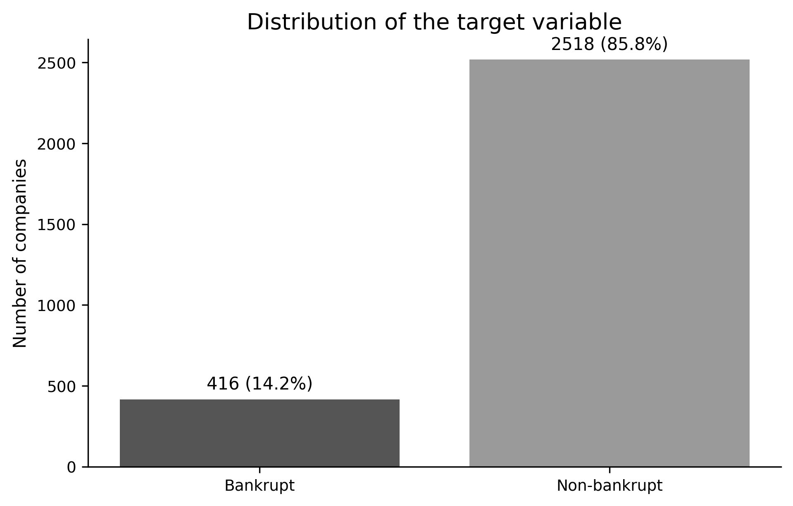
Figure 2. Distribution of the target variable bankrupt.

5. Descriptive Statistics of the Dataset
Before modeling, descriptive statistics of the dataset and graph were calculated. This step is necessary to understand the network structure and the quality of the modeling setup.
Metric | Value
Number of companies | 2 934
Number of original edges | 9 000
Number of unique edges after simplification | 8 993
Share of bankrupt companies | 14.2%
Share of non-bankrupt companies | 85.8%
Graph density | 0.00209
Number of connected components | 9
Largest component size | 2 926 nodes
Average degree | 6.13
Median degree | 6
Diameter of the largest component | 9
Average path length in the largest component | 4.60

The graph is sparse, but most companies belong to one large connected component. This allows the use of network metrics and graph learning methods.
Relationship type | Count | Share
shared_director | 2 309 | 25.7%
supplier | 2 290 | 25.4%
co-investor | 2 217 | 24.6%
parent_company | 2 184 | 24.3%

The relationship types are distributed almost evenly. This is useful because the graph is not dominated by only one type of relationship.
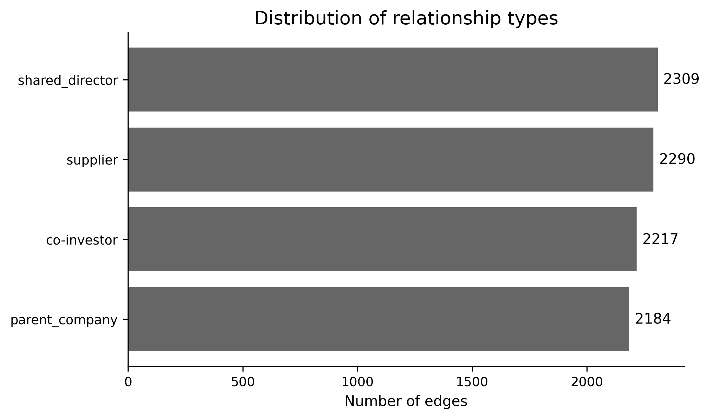
Figure 3. Distribution of corporate relationship types.
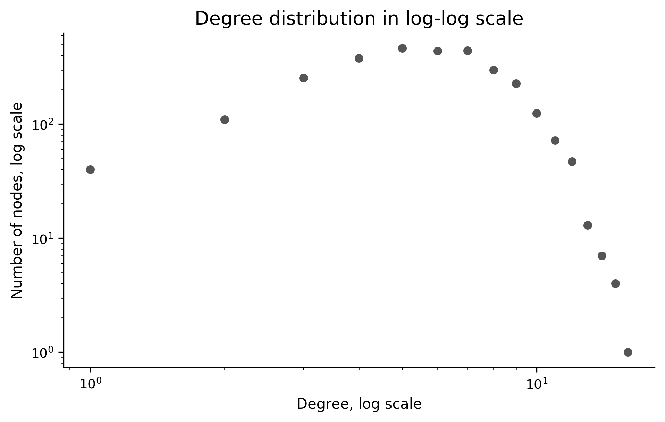
Figure 4. Degree distribution in log-log scale.

6. Model 1: Random Forest with Graph Features
The first model is used as a fair baseline. It combines company-level financial features and graph features extracted from the corporate network.
Financial features: revenue, debt_ratio, liquidity, legal_cases, credit_score.
Graph features: PageRank, degree centrality, and clustering coefficient. These features describe a company’s position in the network and the level of its local connectivity.
To prevent data leakage, graph features are calculated inductively. The train split uses the train subgraph, validation uses the graph available at the validation stage, and test uses the graph available at the evaluation stage. Feature scaling is fitted only on the train data.
Metric | Value
Optimal threshold | 0.1100
ROC-AUC | 0.7871
PR-AUC | 0.2951
Accuracy | 0.6054
Precision | 0.2576
Recall | 0.9365
F1-Score | 0.4041

The key strength of the baseline is very high Recall. This means the model detects most bankrupt companies, but it also produces many false positives. For risk scoring, this can be useful when the main objective is to avoid missing risky firms.

7. Model 2: GraphSAGE on the Corporate Graph
The second model is GraphSAGE. It is a graph neural network that uses node features and the structure of the corporate graph. The model aggregates information from neighboring companies and tries to identify the network signal of bankruptcy risk.
GraphSAGE was trained on the same financial and graph features, while also using the edge structure between companies. Class imbalance was handled by weighting the positive class, and the best model was selected by validation PR-AUC.
The classification threshold was also selected on the validation set using the precision-recall curve and then applied to the test set.
Metric | Value
Optimal threshold | 0.6184
ROC-AUC | 0.7377
PR-AUC | 0.2956
Accuracy | 0.7460
Precision | 0.2906
Recall | 0.5397
F1-Score | 0.3778

GraphSAGE has higher Accuracy and Precision than Random Forest. However, its Recall is lower, meaning that it classifies companies as bankrupt more cautiously.

8. Model Comparison and Results
The main comparison metric is PR-AUC because bankruptcy is a rare positive class. ROC-AUC is reported as an additional metric.
Model | ROC-AUC | PR-AUC | F1-Score
Random Forest + graph features | 0.7871 | 0.2951 | 0.4041
GraphSAGE | 0.7377 | 0.2956 | 0.3778

Model | Accuracy | Precision | Recall | Threshold
Random Forest + graph features | 0.6054 | 0.2576 | 0.9365 | 0.1100
GraphSAGE | 0.7460 | 0.2906 | 0.5397 | 0.6184

By PR-AUC, GraphSAGE is slightly better: 0.2956 compared with 0.2951. The difference is very small, so it is not possible to claim a strong superiority of GraphSAGE. Random Forest performs better by ROC-AUC and F1-Score, while GraphSAGE performs better by Accuracy and Precision.
Overall, both models confirm that network information is useful. Random Forest is better for detecting the maximum number of risky companies, while GraphSAGE provides a more balanced and cautious classification.
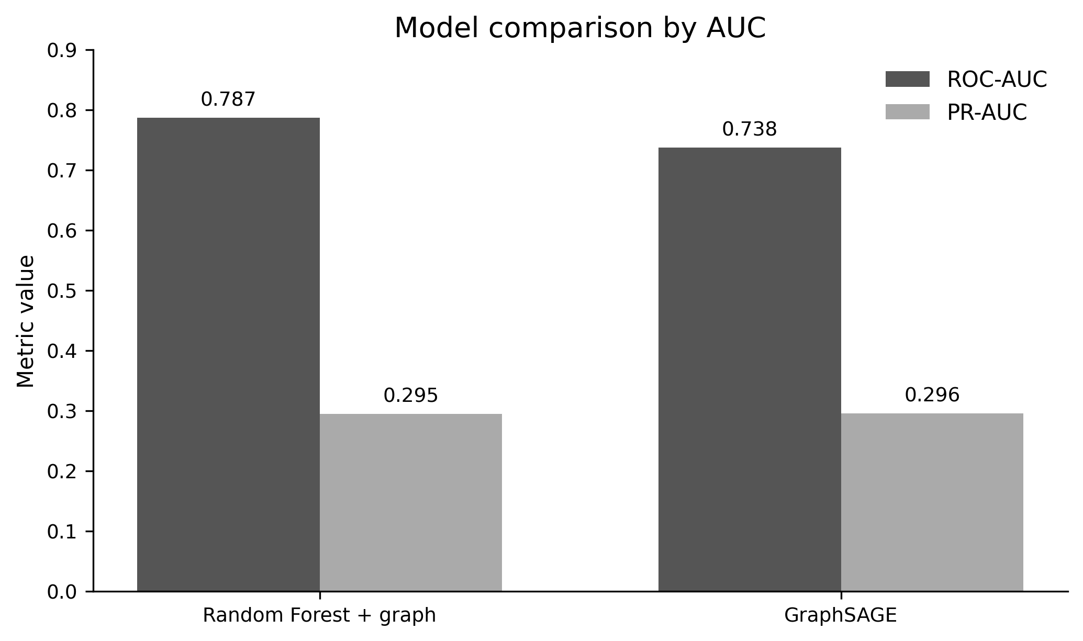
Figure 5. Model comparison by ROC-AUC and PR-AUC.
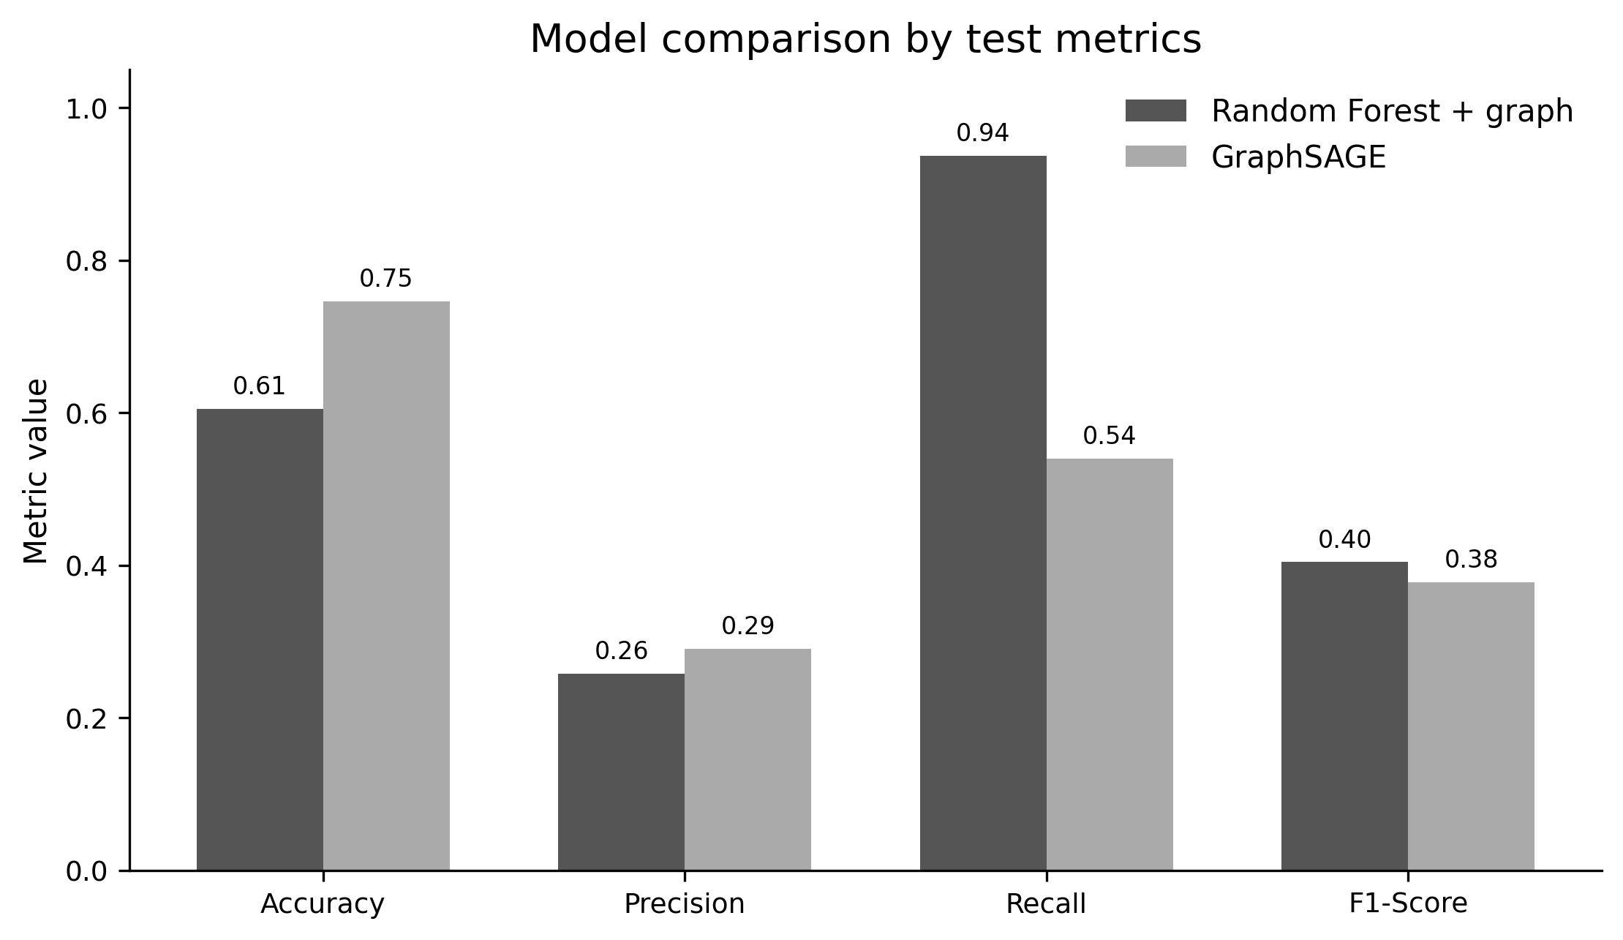
Figure 6. Model comparison by Accuracy, Precision, Recall, and F1-Score.

9. Data Limitations and Issues
• The data are presented as a single snapshot. There is no year-by-year dynamics, so it is difficult to test how risk spreads over time.
• The economic meaning of weight and interaction_freq is not fully transparent.
• There is no industry information. The sector of a company could strongly affect bankruptcy risk.
• There is no geographic information. Region and country could also be important risk factors.
• The share of bankrupt companies is low, so Accuracy should not be treated as the main metric.
• The PR-AUC difference between Random Forest and GraphSAGE is very small, so the result should be interpreted carefully.

10. Conclusion and Interpretation of Results
The hypothesis about the predictive value of network analysis is supported. The use of graph features and the structure of the corporate graph provides useful signal for bankruptcy prediction.
Random Forest with graph features achieves very high Recall of about 94%. This means that the model is effective at detecting risky companies. Its weakness is the large number of false positives, which reduces Precision and Accuracy.
GraphSAGE achieves slightly higher PR-AUC and higher Accuracy. However, its PR-AUC advantage is minimal, so it cannot be claimed that the graph neural network clearly outperforms the classical baseline.
The main conclusion of the project is that moving from isolated company scoring to corporate graph analysis is justified. A company’s network position contains useful information about default risk. In this dataset, both approaches work, but they have different practical effects: Random Forest is better for maximizing risk detection, while GraphSAGE is better for a more balanced classification.

11. Literature
1. Hamilton, W., Ying, Z., Leskovec, J. Inductive Representation Learning on Large Graphs.
2. Breiman, L. Random Forests.
3. Wasserman, S., Faust, K. Social Network Analysis: Methods and Applications.
4. Newman, M. Networks: An Introduction.
5. Course materials: Social Network Analysis, centralities, PageRank, community detection, graph learning.
6. Project dataset: enterprise_nodes_2934.csv, enterprise_edges_9000.csv, enterprise_combined_dataset.csv.

